Appendix “C”
DRESSAGE TEST FOR CHILDREN- I
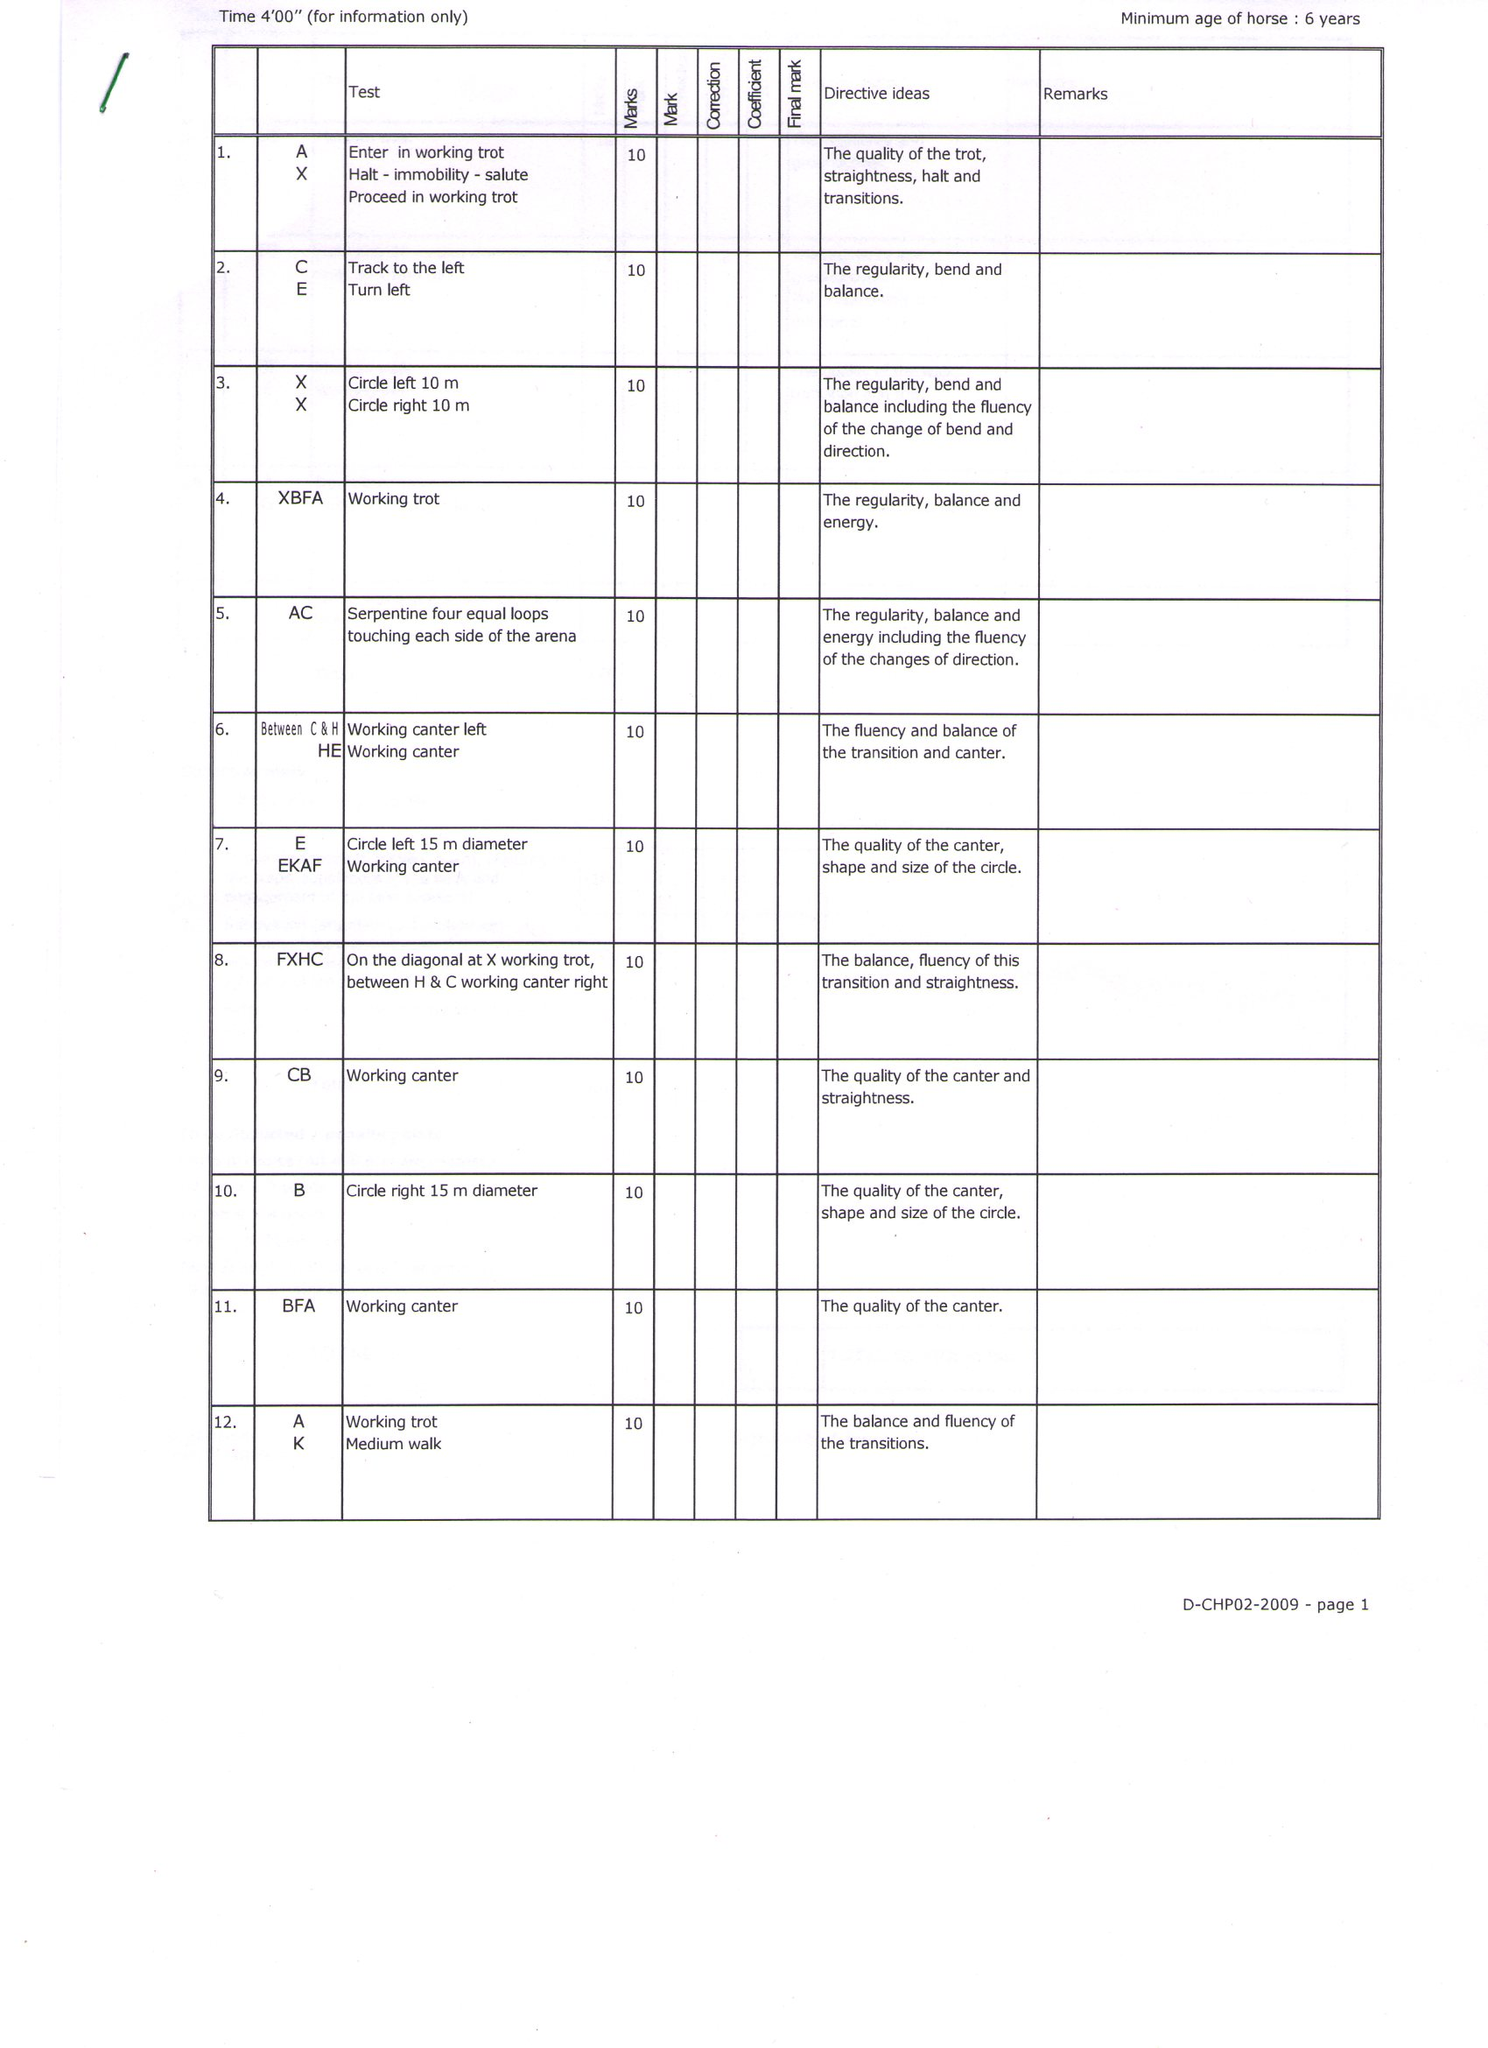

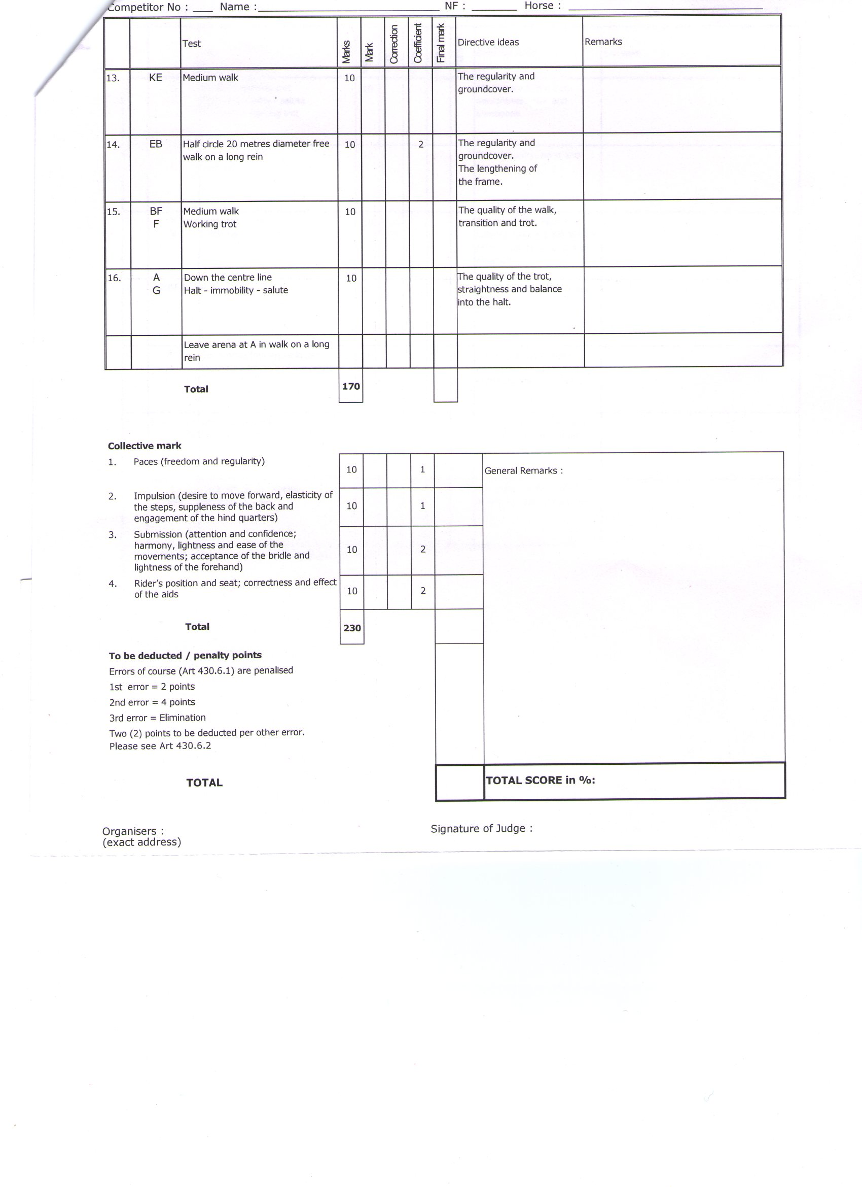

Appendix “D”
DRESSAGE TEST FOR CHILDREN- II
(TO BE RIDDEN IN SNAFFLE & RISING TROT OPTIONAL)
EFI Regn No__________ Name______________________________Horse______________________
Time: min sec (for information only)
 |  | Movement | Note | Coef | Total Points | Remarks
1 | A  X | Enter in working trot  Halt-immobility-Salute  Proceed in working trot |  |  | 10
2 | C  E  EKAF | Track to the left  Circle trot to the left 15 m diameter  Working trot |  |  | 10
3 | FXH  HCMB | Change rein in working trot (Rising)  Working trot |  |  | 10
4 | B  BFA | Circle to the right 15 m diameter  Working trot |  |  | 10
5 | A | Transition to medium walk |  |  | 10
6 | KB  BR | Medium walk with lengthening of the frame  Medium walk |  |  | 10
7 | RMC | Working trot |  |  | 10
8 | C | Proceed in the working canter left |  |  | 10
9 | E | Circle to the left 20 m diameter |  |  | 10
10 | EKAF | Working canter |  |  | 10
11 | FB | Working trot |  |  | 10
12 | BE  EB  BE  EHC | Half circle to the left 20 m diameter  Change of hand through an “S” inside the 20 m circle  Half circle to the right 20 m diameter  Working trot |  |  | 10
13 | C  CMB | Proceed in working canter right  Working canter |  |  | 10
14 | B  BF | Circle to the right 20 m diameter  Working canter |  |  | 10
15 | F | Working trot |  |  | 10
16 | A  I | Down center line  Halt-immobility-salute  Leave the arena in walk on a long rein |  |  | 10
Collective marks

1 | Paces (freedom and regularity) | 10 |  |  | 2
 | Impulsion (desire to move forward, elasticity of the steps, suppleness of the back and engagement of the hind quarters) | 10 |  |  | 2
 | Submission (attention and confidence; harmony, lightness and ease of the movements; acceptance of the bridle and lightness of the forehand) | 10 |  |  | 2
 | Rider’s position and seat, correctness and effect of the aids | 10 |  |  | 2
 | TOTAL | 240
To be deducted
Errors of the course and omissions are penalised

1st Time= 2 marks
2nd Time= 4 marks
3rd Time= Elimination
TOTAL
 | POINTS | %AGE
Judge at E

Judge at H

Judge at C

Judge at M

Judge at B

Total

To be deducted
Errors of course and omissions are penalised
1st Time= 2 marks
2nd Time= 4 marks
3rd Time= Elimination

Appendix “E”
DRESSAGE TEST FOR ONE DAY EVENT- YOUNG RIDER
EFI Regn No__________ Name______________________________Horse______________________
Time: 7min 30 sec (for information only)
 |  | TEST | DIRECTIVE IDEAS | POINTS | MARKS | REMARKS
1 | A | Enter in Working Trot | The entry and straightness. | 10
2 | C  CB  BX  XE | Track to the right  Working trot  Half circle right 10 m diameter  Half circle left 10 m diameter | The Accuracy.  Bend and balance  Half circle left 10 m diameter  The change of bend | 10
3 | EKAF | Working trot | The regularity, balance and engagement. | 10
4 | FXH  H | Change rein in medium trot (Rising)  Working trot | The lengthening and the transitions. | 10
5 | HM  MXK  K | Working trot  Change rein in medium trot  Working trot | The lengthening and regularity of the steps. The balance and the transitions. | 10
6 | KF  FBM  MC | Working trot  2 loops in working trot (distance from track, 4-5 m each)  Working trot | The regularity of the loops and the trot. The balance and fluency. The bend. | 10
7 | C | Halt-rein-back 4-5 steps  Proceed in medium walk without halting. | The halt. The rein back. The transitions | 10
8 | CHBK | Medium walk | Regularity and moderate lengthening of steps. | 10
9 | KA  A | Working trot  Circle 10 m diameter in working trot | The bend. The regularity, the balance and the accuracy. | 10
10 | A  AF | Working canter left  Working canter | The transition. The impulsion and the regularity | 10
11 | FM  M | Medium canter  Working canter | The lengthening and impulsion. The transitions | 10
12 | MHE  EX  X | Working canter  Half circle left 10 m diameter  Simple change of leg | The regularity of the canter and the bend. The transitions with A clear walk at X (3-5 steps). The balance and engagement. | 10
13 | XB  BFAK | Half Circle right 10 m diameter  Working canter | The regularity of the canter and the bend.  The balance. | 10
14 | KH  H | Medium canter  Working canter | The lengthening and impulsion. The transition. | 10
15 | HMB  BX  X | Working canter  Half circle right 10 m diameter  Simple change of leg | The regularity of the canter and the bend. The Transitions with A. clear walk at X (3-5 steps).The balance and engagement. | 10
16 | XE  EK  K | Half circle left 10 m diameter  Working canter  Working trot | The regularity of the canter. The bend and the balance. The transactions. | 10
17 | KA  A  G | Working trot  Down Center line  Halt-immobility-salute. | The straightness. The transition to halt. Immobility during salute. | 10
 |  |  | SUB-TOTAL | 170

Leave arena at walk on long rein at A.
 | COLLECTIVE MARKS | COEFFICIENT | POINTS | MARK | REMARKS
 | Paces (freedom and regularity) | 2 | 10
 | Impulsion (desire to move forward, elasticity of the steps and engagement of the hind quarters) | 2 | 10
 | Submission (attention and obedience, lightness and ease of the movements; acceptance of the bridle) | 2 | 10
 | Position and seat of the rider, correct use of the aids | 2 | 10
 |  |  | TOTAL | 250

TO BE DEDUCTED: ERRORS OF THE COURSE AND OMISSIONS ARE PENALISED:

1ST TIME : 2 MARKS…………………….
2ND TIME : 4 MARKS…………………….
3RD TIME : ELIMINATION……………….

TOTAL

NOTE: THE WORKING MEDIUM AND EXTENDED TROTS MUST BE EXECUTED “ SITTING “ UNLESS THE TERM “ RISING “ IS USED IN THE TEST.

Appendix ‘E’

Annexure I
DRESSAGE TEST FOR ONE DAY EVENT- YOUNG RIDER
EFI Registration No__________ Name______________________________Horse______________________
Time: 7min 30 sec (for information only)
 |  | TEST | DIRECTIVE IDEAS | PTS | MARKS | REMARKS
1 | A | Enter in Working Trot | The entry and straightness. | 10
2 | C  CB  BX  XE | Track to the right  Working trot  Half circle right 10 m diameter  Half circle left 10 m diameter | The Accuracy.  Bend and balance  Half circle left 10 m diameter  The change of bend | 10
3 | EKAF | Working trot | The regularity, balance and engagement. | 10
4 | FXH  H | Change rein in medium trot (Rising)  Working trot | The lengthening and the transitions. | 10
5 | HM  MXK  K | Working trot  Change rein in medium trot  Working trot | The lengthening and regularity of the steps. The balance and the transitions. | 10
6 | KF  FBM  MC | Working trot  2 loops in working trot (distance from track, 4-5 m each)  Working trot | The regularity of the loops and the trot. The balance and fluency. The bend. | 10
7 | C | Halt-rein-back 4-5 steps  Proceed in medium walk without halting. | The halt. The rein back. The transitions | 10
8 | CHBK | Medium walk | Regularity and moderate lengthening of steps. | 10
9 | KA  A | Working trot  Circle 10 m diameter in working trot | The bend. The regularity, the balance and the accuracy. | 10
10 | A  AF | Working canter left  Working canter | The transition. The impulsion and the regularity | 10
11 | FM  M | Medium canter  Working canter | The lengthening and impulsion. The transitions | 10
12 | MHE  EX  X | Working canter  Half circle left 10 m diameter  Simple change of leg | The regularity of the canter and the bend. The transitions with A clear walk at X (3-5 steps). The balance and engagement. | 10
13 | XB  BFAK | Half Circle right 10 m diameter  Working canter | The regularity of the canter and the bend.  The balance. | 10
14 | KH  H | Medium canter  Working canter | The lengthening and impulsion. The transition. | 10
15 | HMB  BX  X | Working canter  Half circle right 10 m diameter  Simple change of leg | The regularity of the canter and the bend. The Transitions with A. clear walk at X (3-5 steps).The balance and engagement. | 10
16 | XE  EK  K | Half circle left 10 m diameter  Working canter  Working trot | The regularity of the canter. The bend and the balance. The transactions. | 10
17 | KA  A  G | Working trot  Down Center line  Halt-immobility-salute. | The straightness. The transition to halt. Immobility during salute. | 10
 |  |  | SUB-TOTAL | 170

Leave arena at walk on long rein at A.

 | COLLECTIVE MARKS | COEFFI  CIENT | POINTS | MARK | REMARKS
 | Paces (freedom and regularity) | 2 | 10
 | Impulsion (desire to move forward, elasticity of the steps and engagement of the hind quarters) | 2 | 10
 | Submission (attention and obedience, lightness and ease of the movements; acceptance of the bridle) | 2 | 10
 | Position and seat of the rider, correct use of the aids | 2 | 10
 |  |  | TOTAL | 250

TO BE DEDUCTED: ERRORS OF THE COURSE AND OMISSIONS ARE PENALISED:

1ST TIME : 2 MARKS…………………….
2ND TIME : 4 MARKS…………………….
3RD TIME : ELIMINATION……………….

TOTAL

NOTE: THE WORKING MEDIUM AND EXTENDED TROTS MUST BE EXECUTED “SITTING” UNLESS THE TERM “RISING” IS USED IN THE TEST.
.

